Name: Ngô Tiến Tú

ID: 20119175

**EXPERIMENT NO.1**

First, open the terminal, go to the cds_work directory with the command "cd_cds_work". Then, open the cadence virtuoso software with the command "virtuoso". A menu appears, select tools in the toolbar and select Library Manager... Then the program will initialize as shown below.

To create a library, you choose file -> new -> Library. Next, give the library a name -> click apply -> Select Technology File for New Library -> Attach to an existing technology library -> Attach Library to Tech Library -> gpdk090.

To create Simulation Design, choose File -> New -> Cell View -> New File -> Name the file in the Cell box.

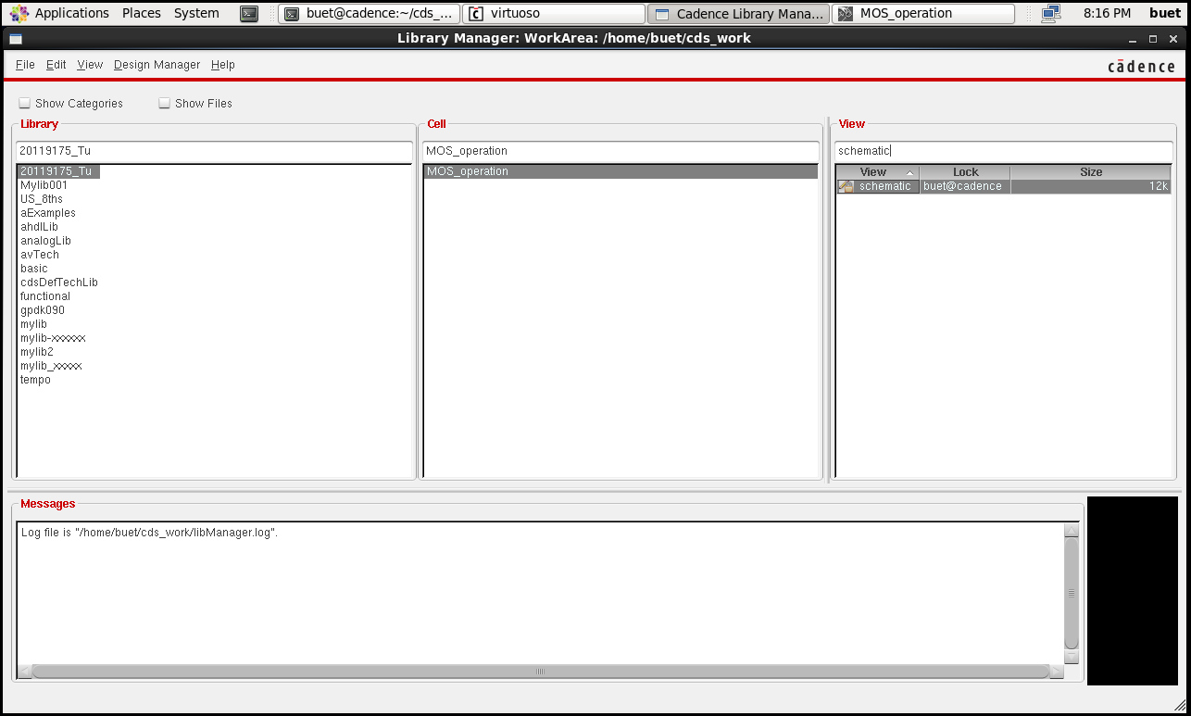

Then we press I to get components, click browse -> point to gpdk090. First, we have to get the symbol of nmos here.

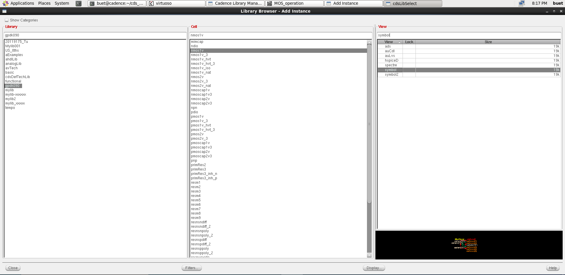

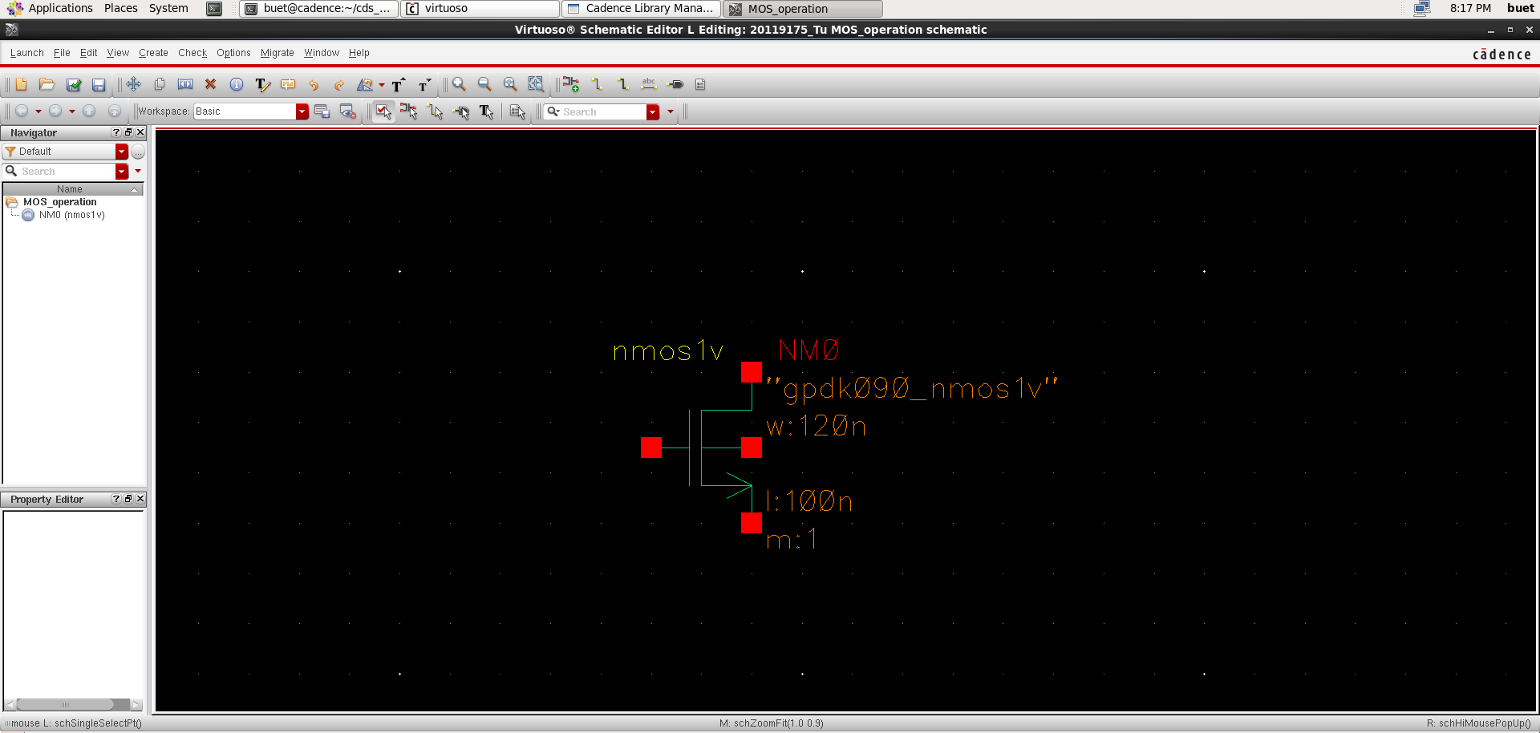

Then we get the vdc source from analogLib library.

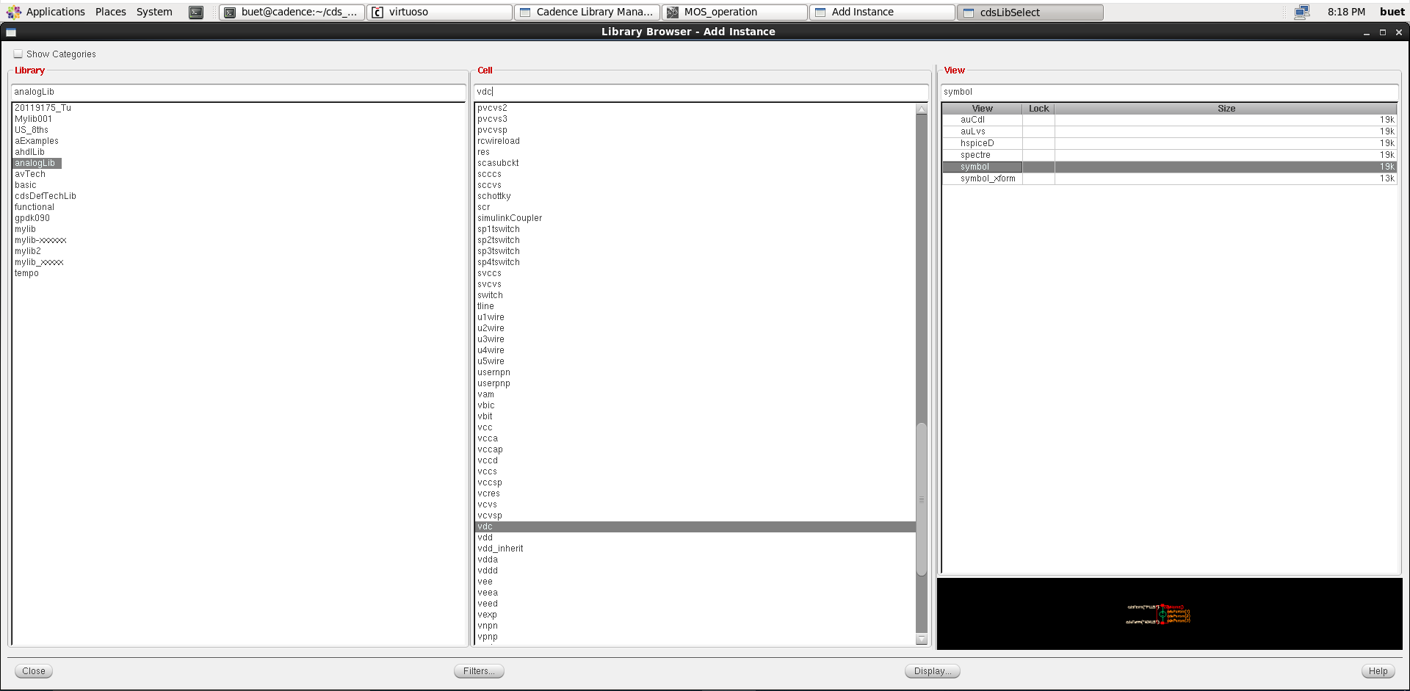

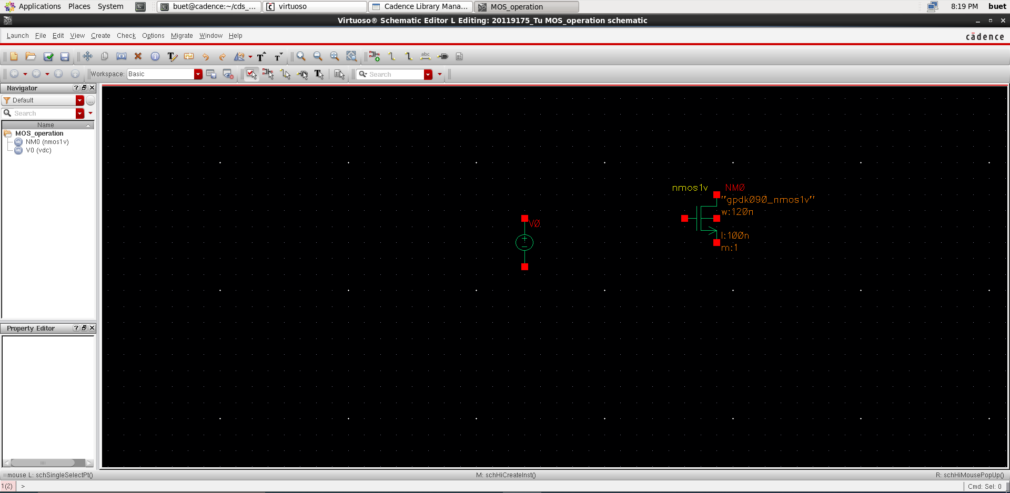

Take gnd to attach to create voltage for vdc source.

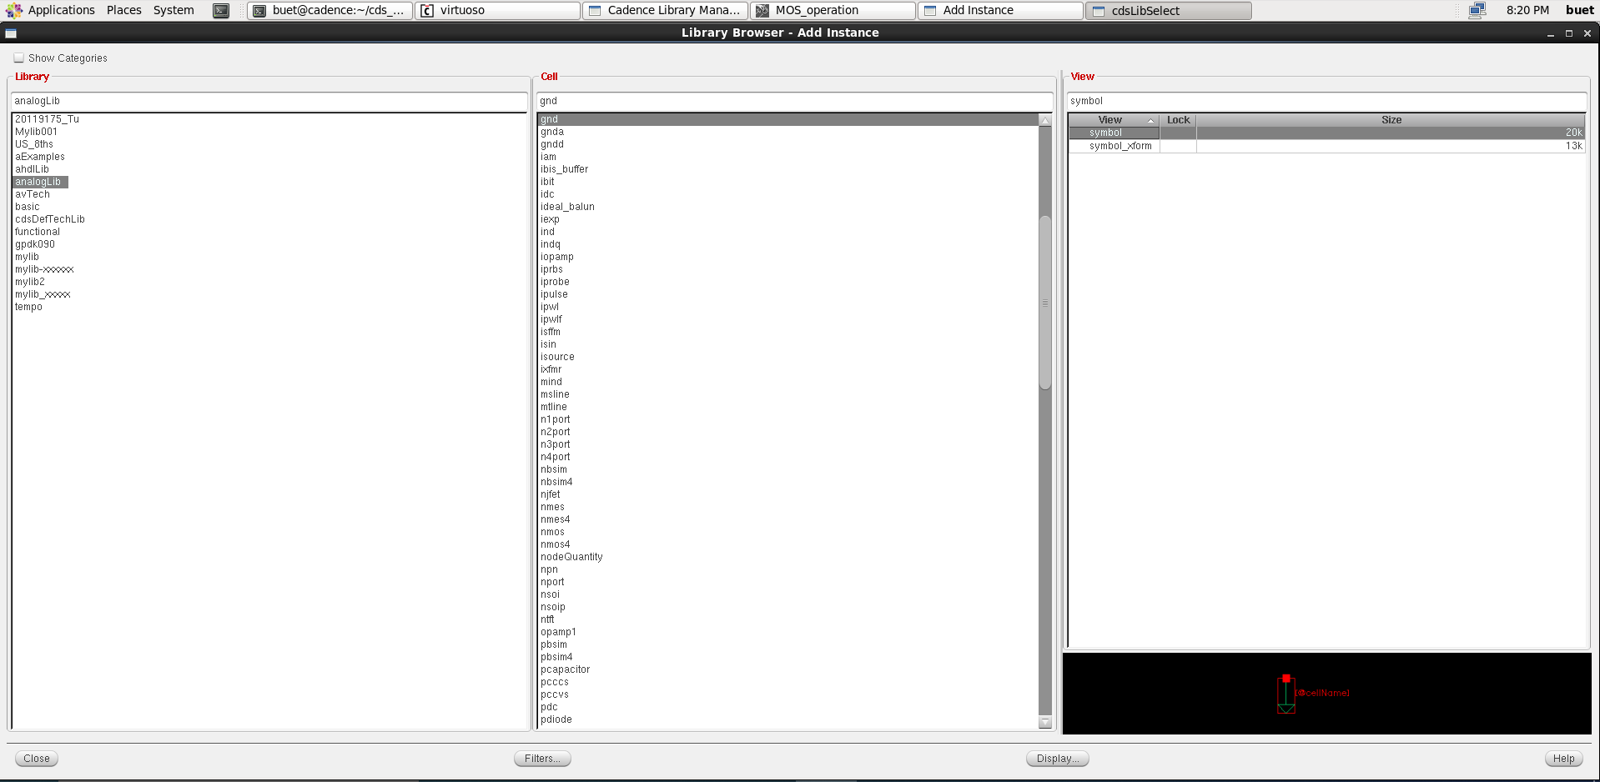

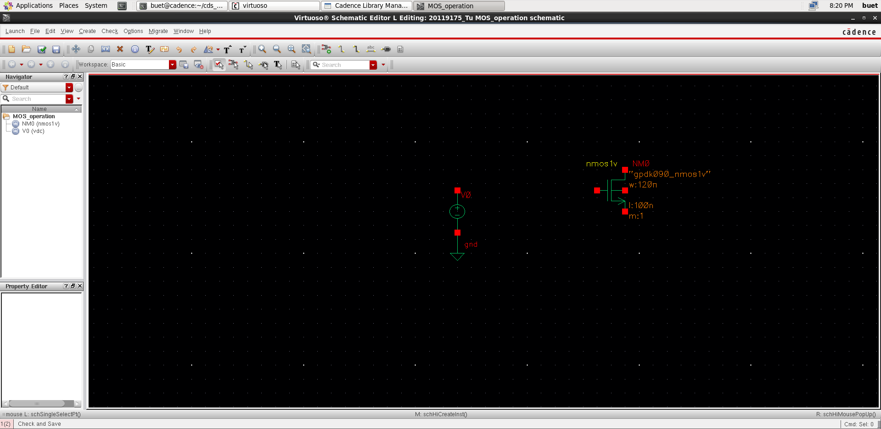

Set the value of the source vdc to 1V.

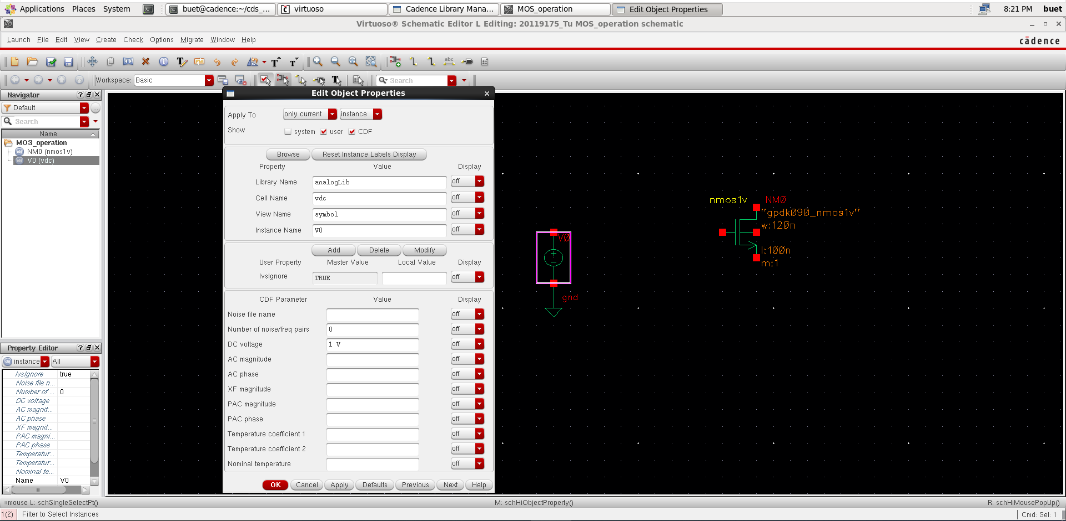

Wire between terminals of nmos and source.

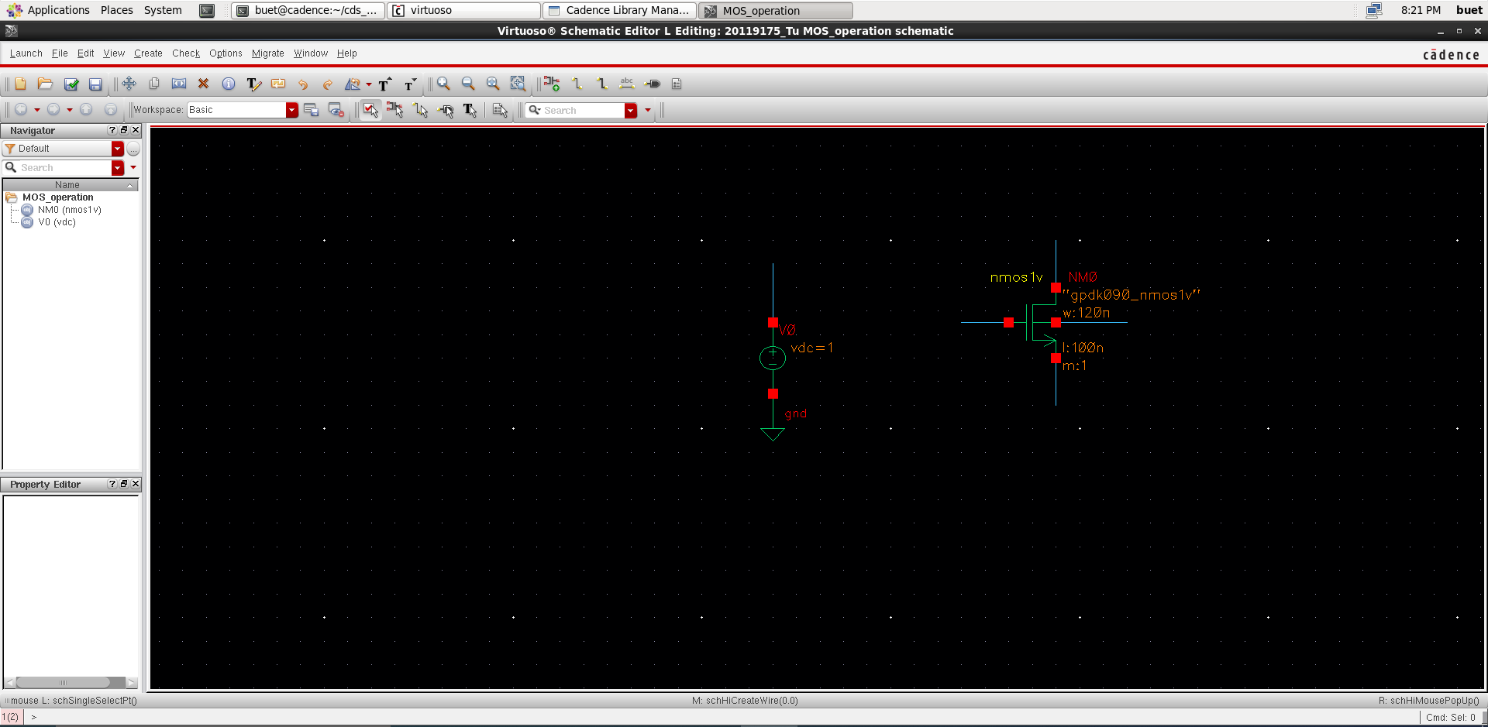

Name the labels for the common junctions.

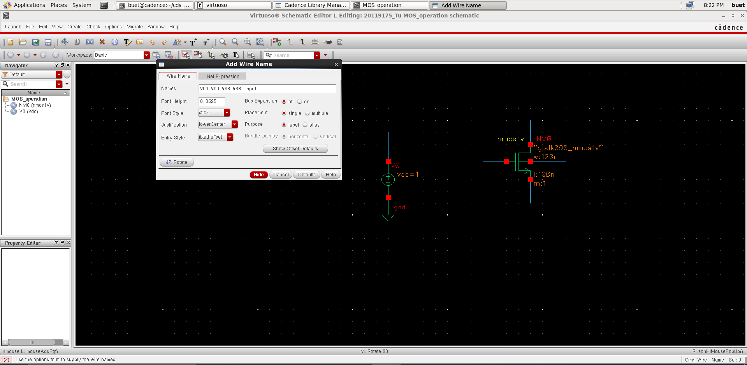

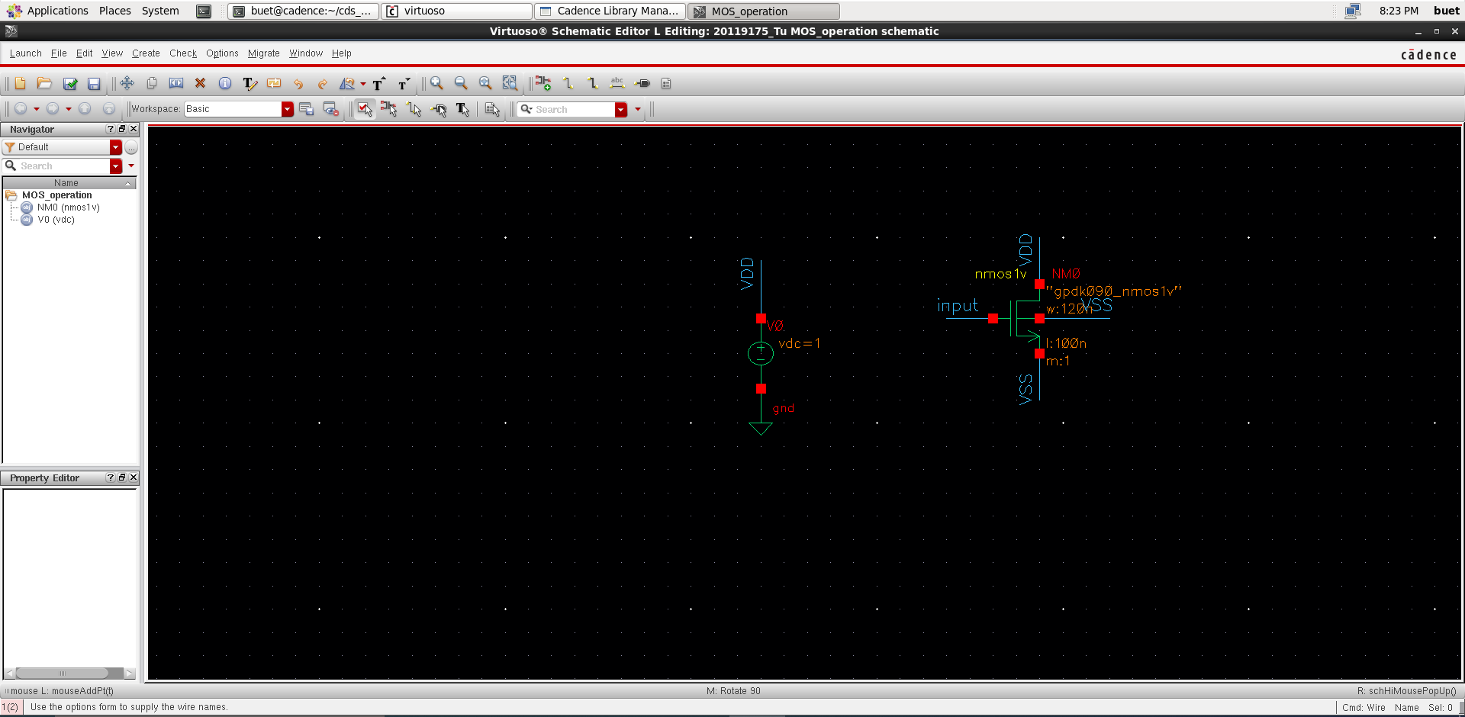

Copy the source vdc, change the value to 0V to create VSS.

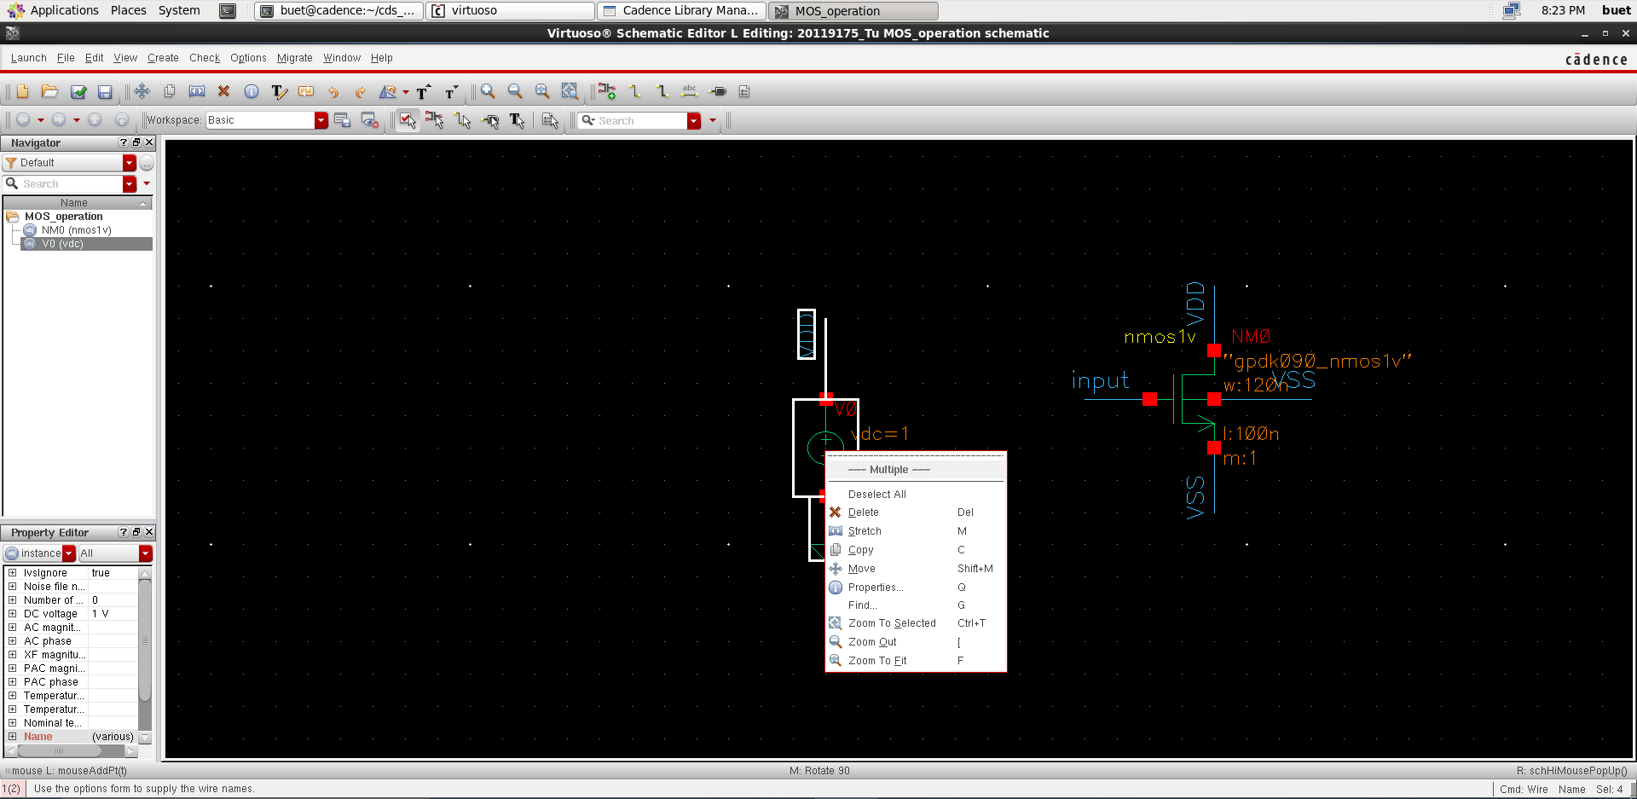

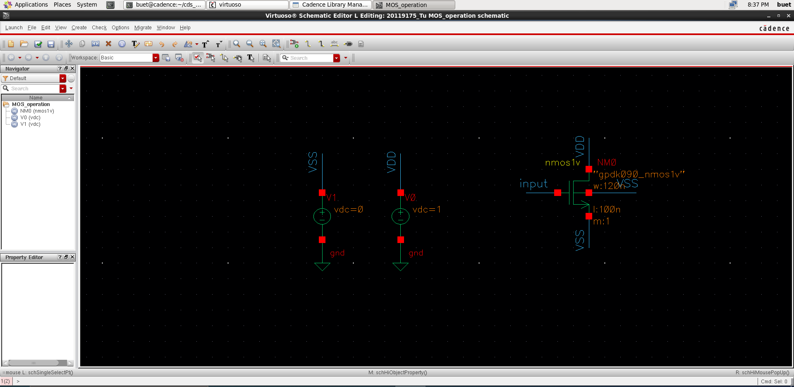

Get pulse source to create input.

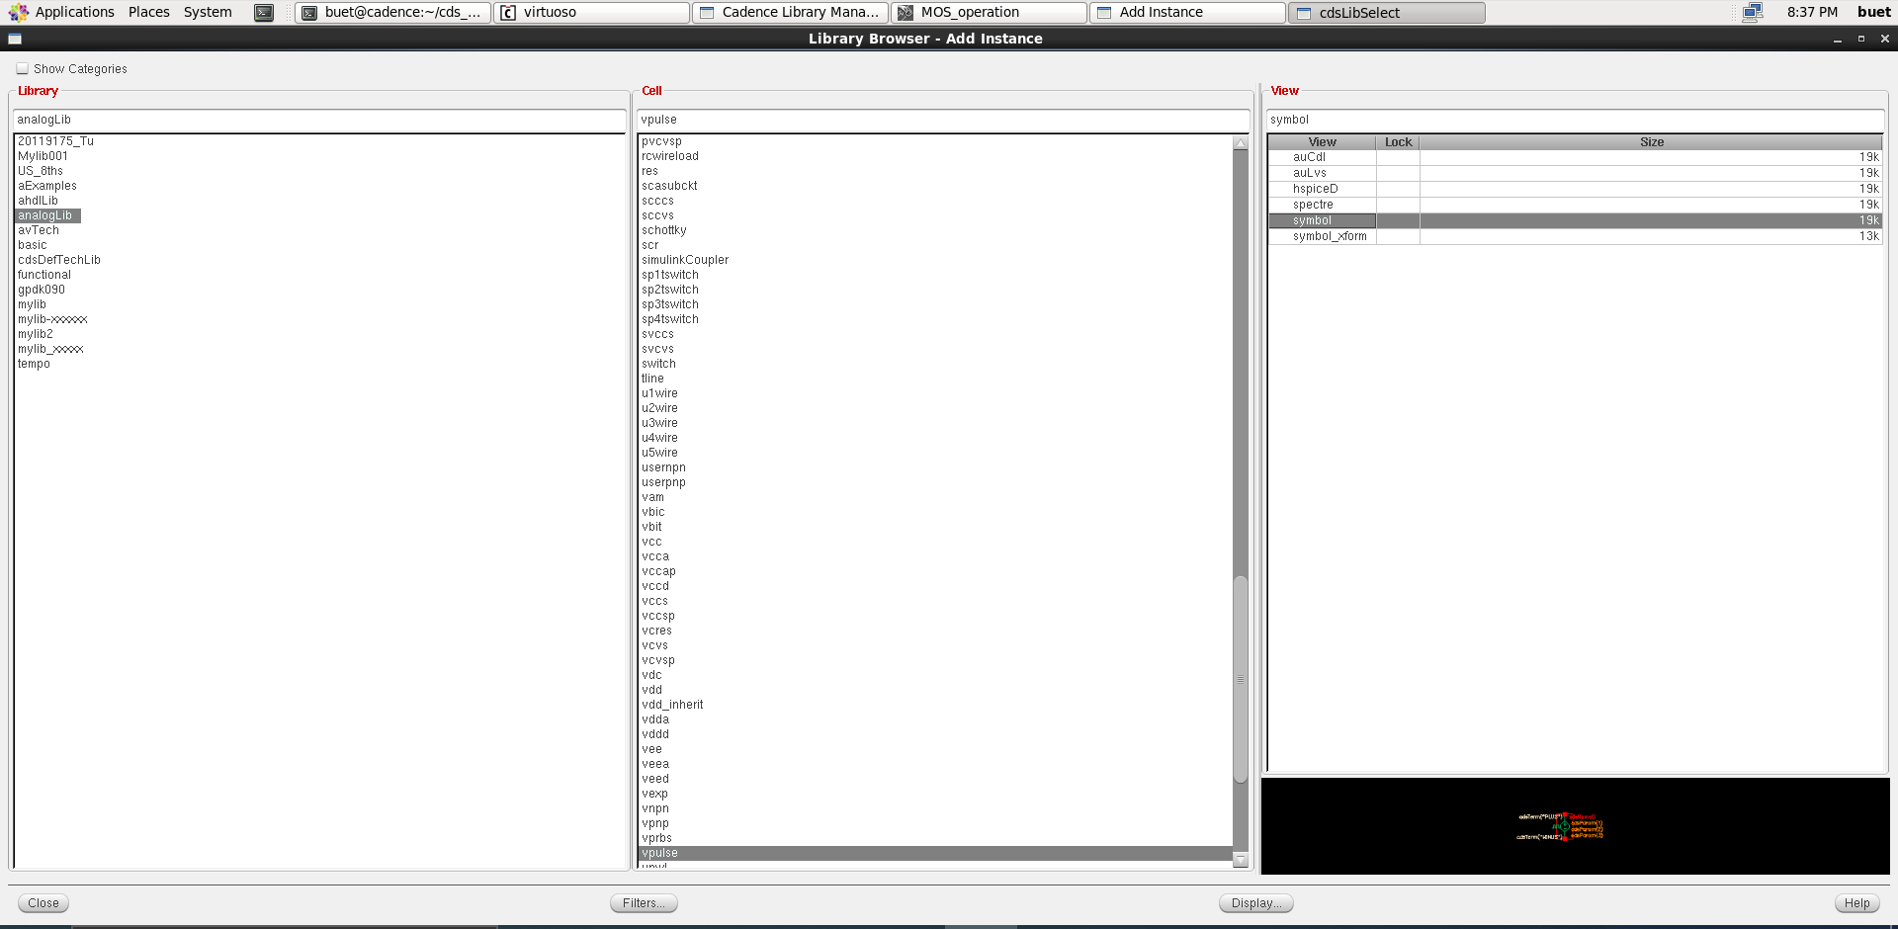

Initialize the values for the pulse source as shown below.

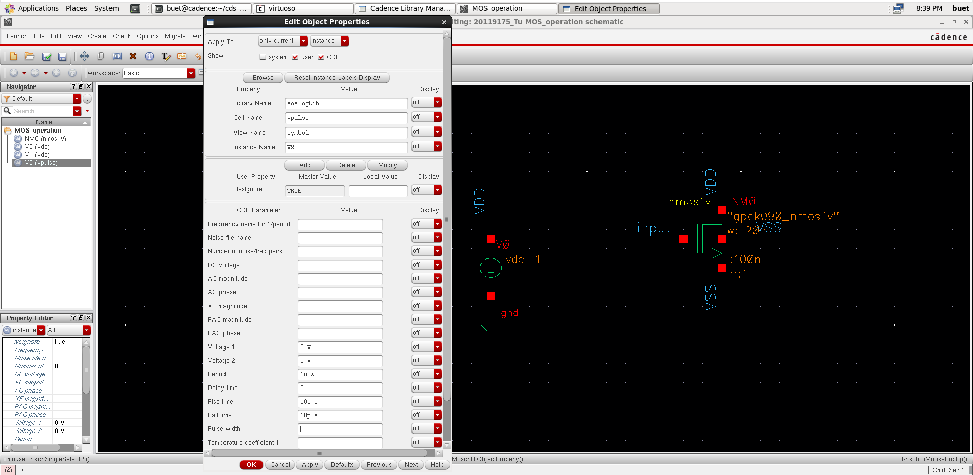

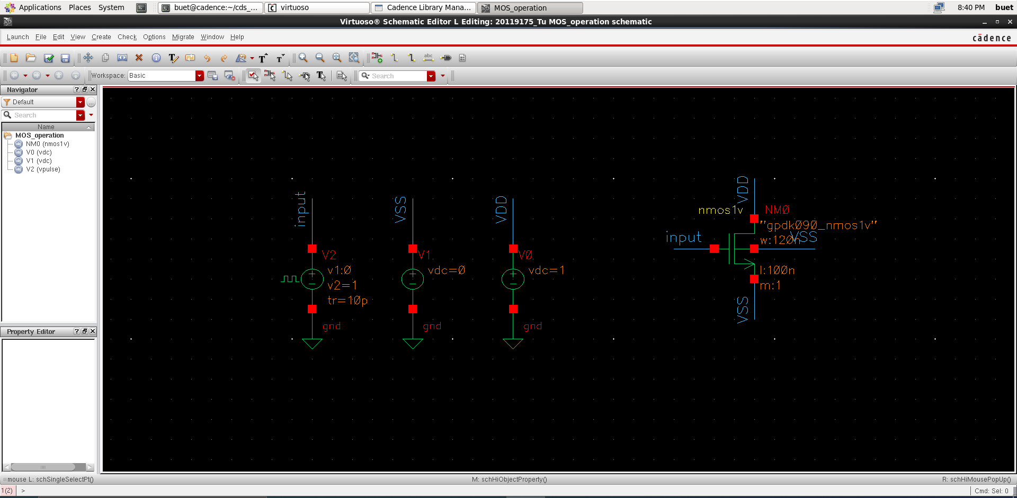

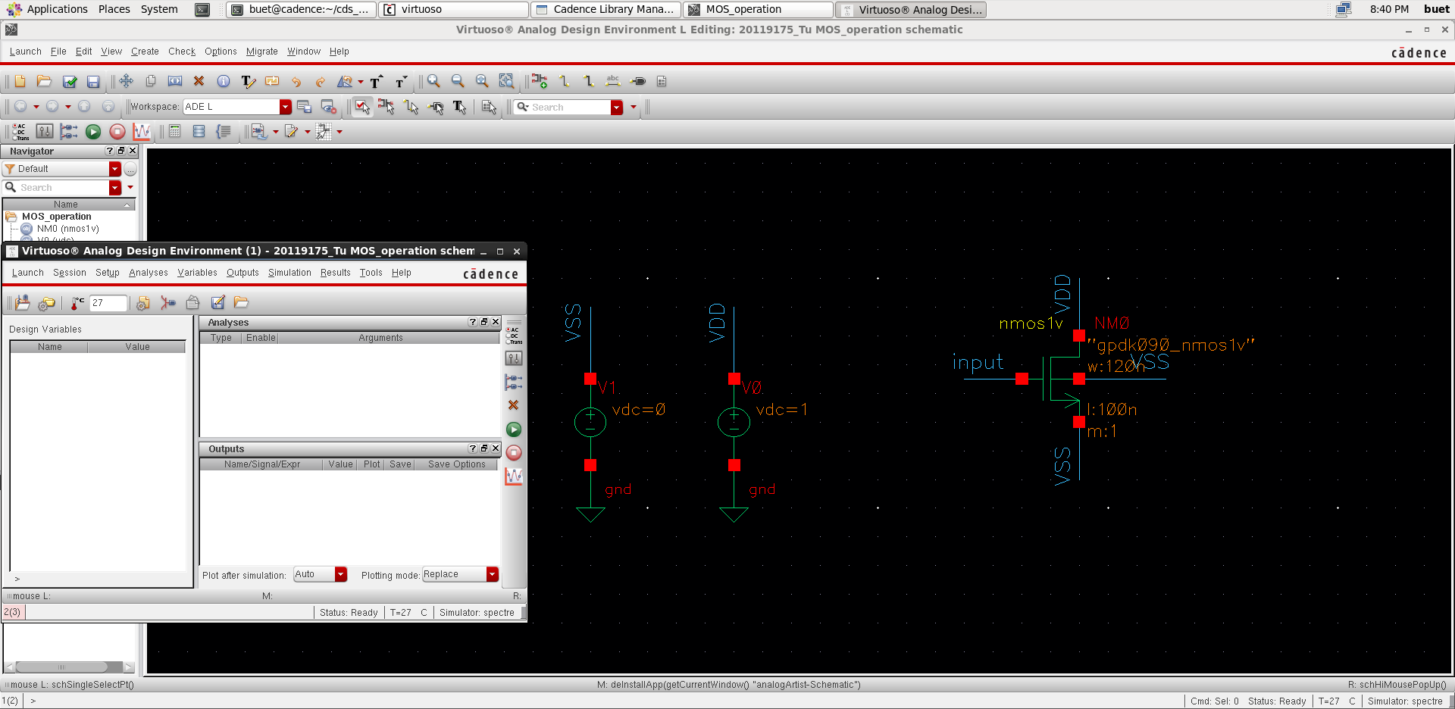

Check setup library for circuit simulation.

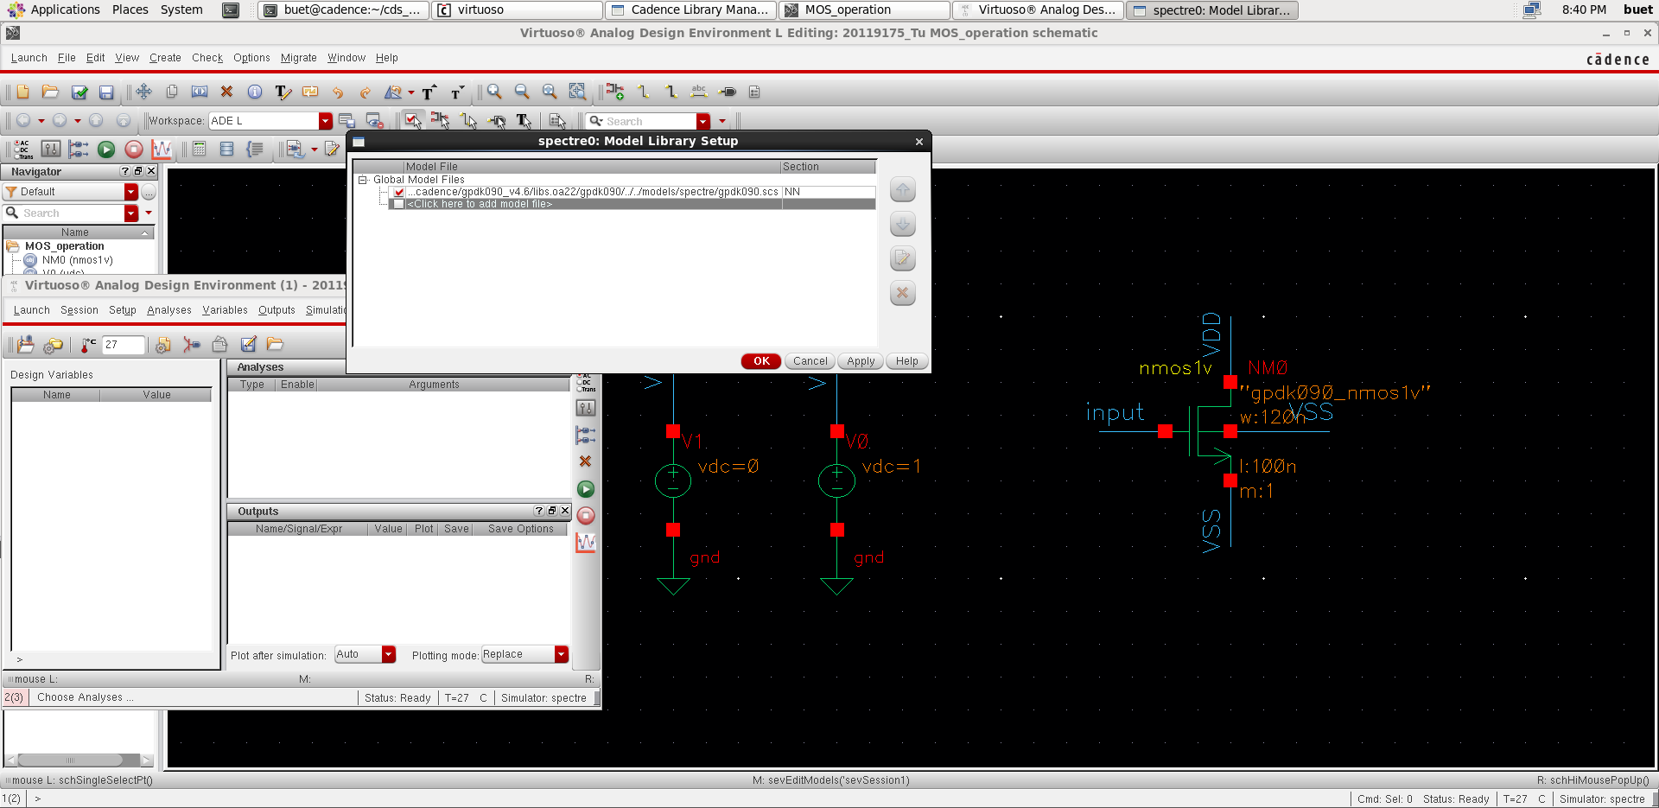

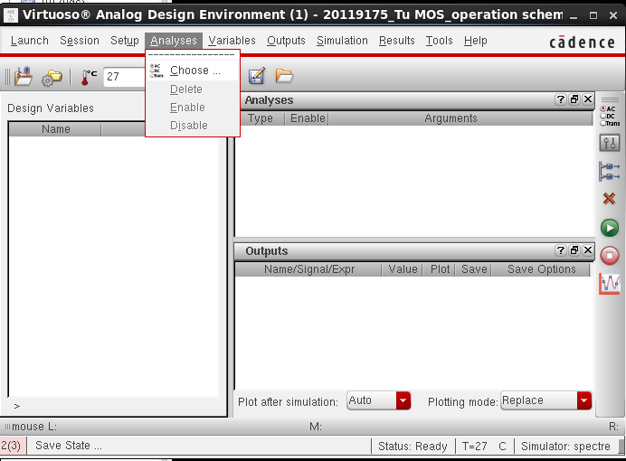

Choose simulation time to be 1 microsecond.

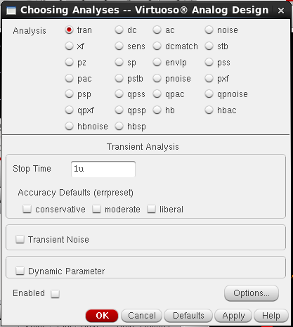

Select wires to draw voltage and points to draw current in simulation.

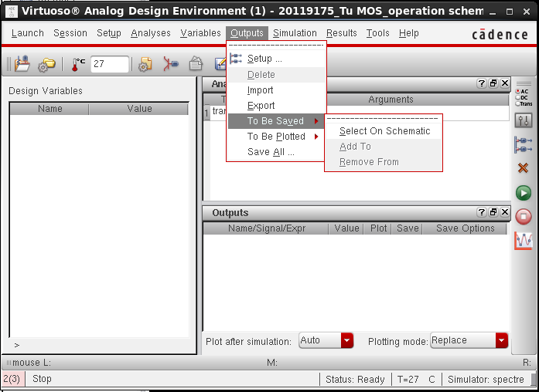

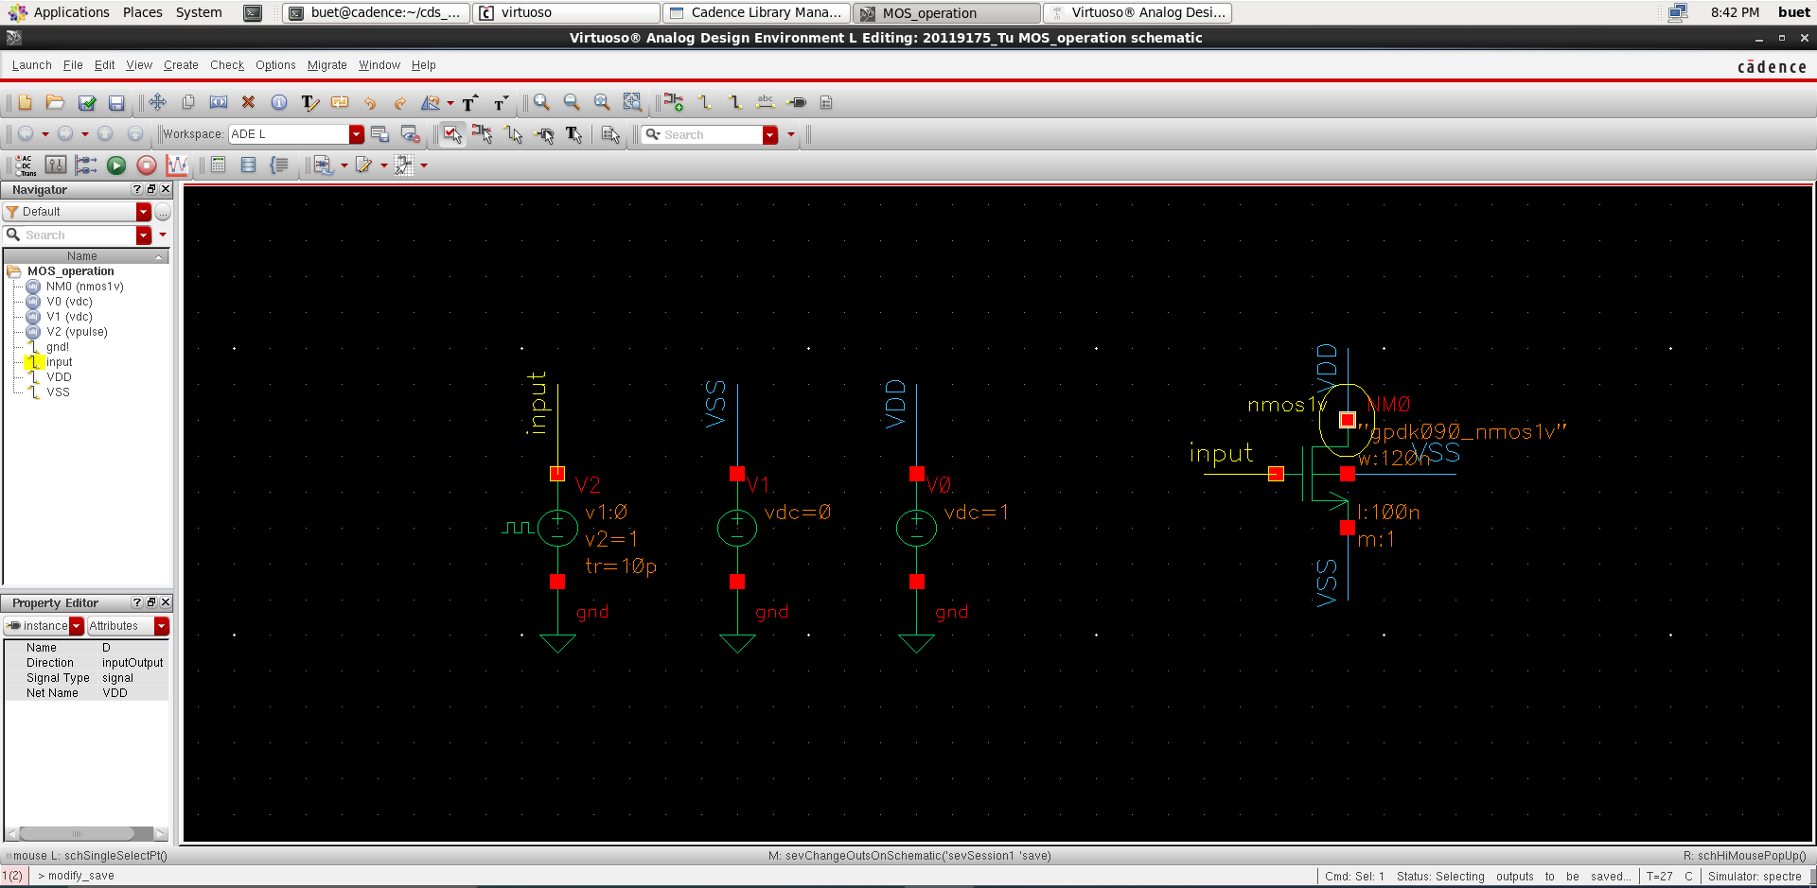

Press run. And the following figures are the result of simulation.

